In this simple diagram of a file system, you see inodes are created first and then followed by the data blocks. There are inode numbers for each file or directory, they contain most of the information about the file or directory.

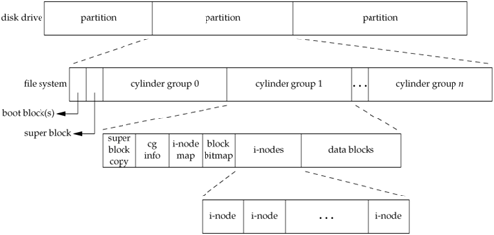

Zooming in the inode and data blocks, we see a mix of files and directories are created. In the directory block, just the inode and filenames of the files are listed, in the data block, content of the files are listed.

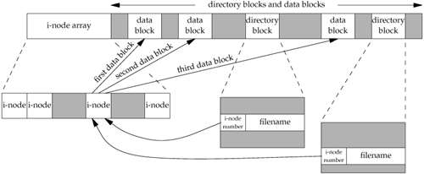

In the directory block, there must be two entries at least: one for the current folder (DOT ) and one for the parent folder ( DOT DOT ). If there are only two entries , then the directory is empty and can be deleted.

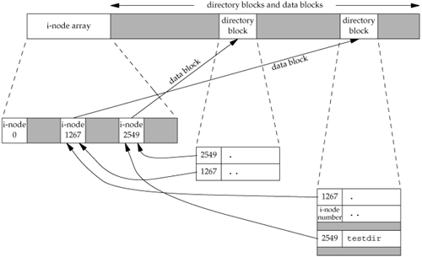

Here is the information on inodes and structures

<https://en.wikipedia.org/wiki/Inode_pointer_structure>